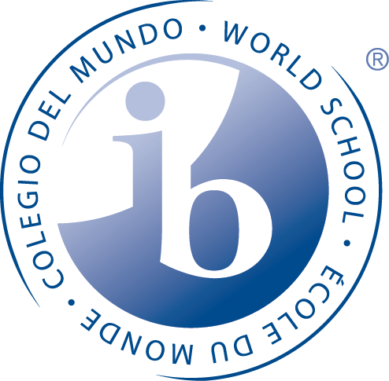
Kellogg School
International Baccalaureate Programme
Language Policy 2016-2017

- Language Overview

- Language Philosophy

- Language Beliefs

- Language Profile

- Language of Instruction

- Considerations

- Language Overview

Language is at the core of all learning. It involves skills and literacy, as well as relationships to meanings. Developing the mother tongue of all learners leads to personal growth and emotional well-being. Learning a second language is crucial for success across all levels of the IB programmes. Communication in a variety of ways in more than one language is essential to the idea of an international education, a key component of IB practice.

The IB learner profile describes a communicator as one who can understand and express ideas and information confidently and creatively in more than one language. Each of the IB programmes aims to develop learners who can use language as a means to create a better and more peaceful world.

- Language Philosophy

The Kellogg School’s IB Middle Years Programme is committed to the goal of each student achieving their potential academically and socially in a global society. We believe that language is the foundation for all learning and as such all teachers are language teachers. Learning more than one language is essential to an international education: enriching cultural and intercultural understanding. Through language all students acquire knowledge and develop skills to be successful. We believe that language acquisition is the key for learning, thinking and communicating enabling learners to become citizens of the world.

- Language Beliefs

- The responsibility for the on-going language development for MYP students in the Chicago Public Schools belongs to teachers, students and parents.
- The ability to communicate in a variety of modes in more than one language is essential to the concept of international education and promotes intercultural understanding.
- Providing opportunities and resources to all learners in order to promote proficiency in language acquisition is essential.
- Learning experiences are provided for students in the mother tongue as well as a second language of school choice.
- Language learning experiences will vary in complexity based upon the student need.
- Assessment of language acquisition is on-going and students and parents are provided feedback on progress.
- Languages of teaching and learning will be based on the needs of learners.
- Accommodations are made using differentiated instruction according to individual needs.
- The four dimensions of teaching (Cummins,2007) language to promote engagement: activate prior knowledge, scaffold meaning, extend language and affirm identity are encouraged.
- The school is responsible for identifying the language needs of each learner.
- Consideration will be made for addressing the needs of those learning in a language other than their mother tongue.

- Language Profile

IB Middle Years Programme
- Support the development of the mother tongue for all students enrolled in the
programme
- Provide opportunities for all students to learn further languages including, English
- Language Acquisition instruction is provided over the course of each year for a minimum of 50-hours of instruction
- Promote a stimulating learning environment for students who do not speak the language
- Integrate the learning of languages into all subject areas
- Build capacity amongst all staff to activate learner’s prior understanding
- Collaborate with interdisciplinary team to differentiate tasks leading to further background knowledge
- Implement scaffolding strategies to foster learner’s independence for their own learning
- Provide additional language instruction or tutoring when necessary
- Provide literacy support and practice for learners to maintain high expectations.
- Provide resources and materials in mother tongue language

- Periodic Review
1. The language policy will undergo review by the administration and the IB MYP team of teachers in May each year. This will allow for the examination of procedures, current practices and new developments that may impact the policy. This will be facilitated by the IB MYP language acquisition teacher and the MYP coordinator.
2. The language policy will be reviewed with students at the start of each new school year by the language acquisition teacher. The language policy will be reviewed with all parents at the IB parent meeting that is held each September.
3. The language policy will be included in the school webpage and be available for anyone who visits the Kellogg School website.
4. Each student will receive a copy of the language policy in the opening of school packet to be reviewed and shared with parents.

- Language of Instruction

- Kellogg School: Mother Tongue English Language Acquisition Spanish

- Considerations

- Differentiated instruction methods are used to address the needs of those learning in a language other than the mother tongue as needed.
- English Language Learner (ELL) and immersion programs support the language acquisition skills if needed. Books, audio tapes, and online resources facilitate language competencies for all learners.
- All IB Programme team members will be introduced to the language policy at the onset of each new school year.
- The language policy will be reviewed during the self-study to ensure that this document is current and has the input of current stakeholders. The teachers, staff, students and parents are committed to fostering quality language opportunities for all students.
- As learners move through inquiry in the MYP the use and range of language competencies will allow for success.

